Code Smells-Bernardo Carvalho 60012

Class location:

\ganttproject\src\main\java\net\sourceforge\ganttproject\GanttProject.java

code smell- A lot of unnecessary commentary.

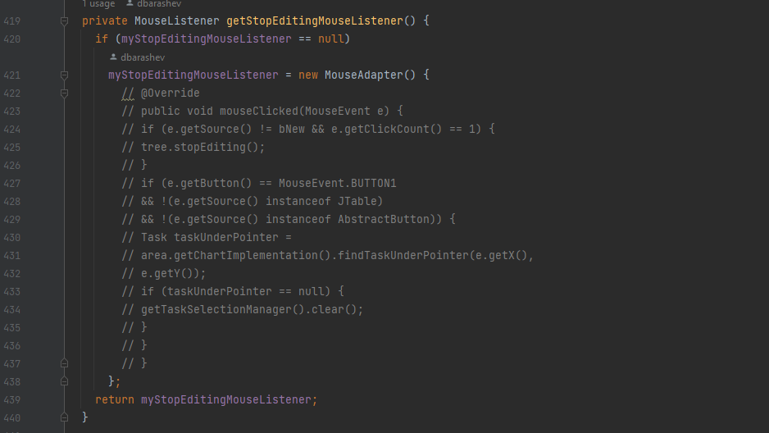

Class location:

\ganttproject\src\main\java\net\sourceforge\ganttproject\gui\AbstractPagesDialog.java

code smell- Massive method, perhaps there is a better way to distribute it in a group of smaller methods.

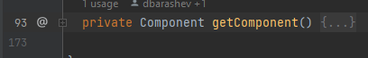

Class location:

\ganttproject\src\main\java\net\sourceforge\ganttproject\gui\FileChooserPageBase.java

code smell- This class has over 400 lines of code and it’s not even the system. Perhaps it should be spread out between smaller classes.

